Two Way Data Binding

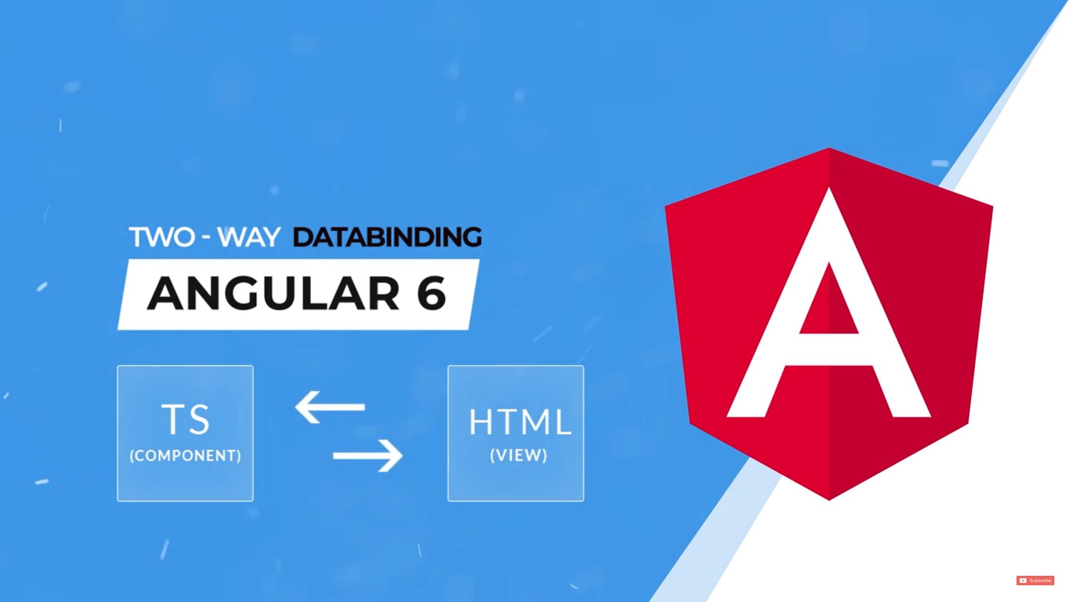

<input type="text" id="" name="" (click) [value]= “username”/>

<input type="text" id="" name="" (click) [value]= “username” [()]/>

Two way binding uses Event Binding & Property Binding Both

------------------------------------------------------------------------------------------------------------------

<button (click) ="OnClick(name)"> Click </button>

<input type="text" id="" name="" [(ngModel)] ="userName"/>

UserName is

{{userName}}

userName : string ="";

To use ngModel , we have to import FormsModule(in AppModule.ts file)

import {FormsModule} from '@angular/forms';

imports: [

    BrowserModule ,

    FormsModule

  ],